sudo apt update

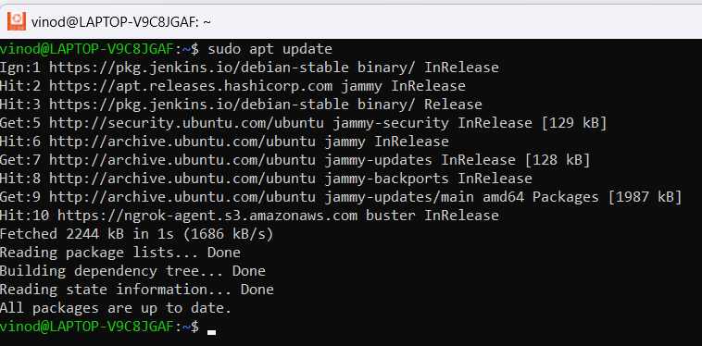

sudo apt install -y curl wget apt-transport-https

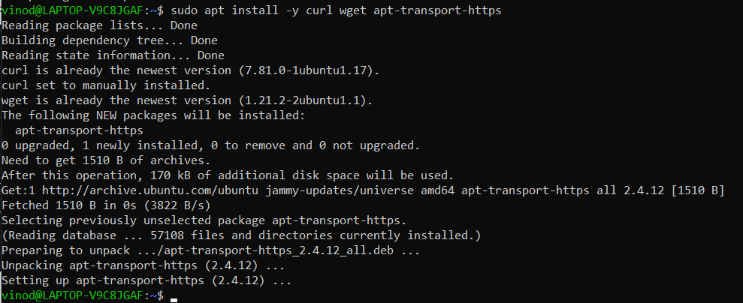

curl -LO https://storage.googleapis.com/minikube/releases/latest/minikube-linux-amd64

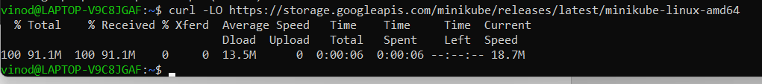

sudo install minikube-linux-amd64 /usr/local/bin/minikube



minikube version

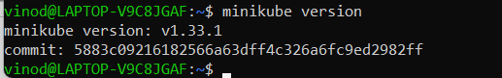

curl -LO https://storage.googleapis.com/kubernetes-release/release/`curl -s https://storage.googleapis.com/kubernetes-release/release/stable.txt`/bin/linux/amd64/kubectl

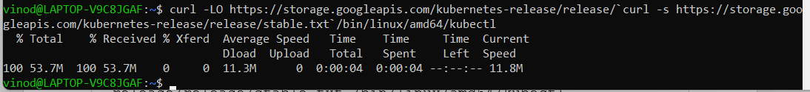

chmod +x kubectl



sudo mv kubectl /usr/local/bin/



kubectl version -o yaml

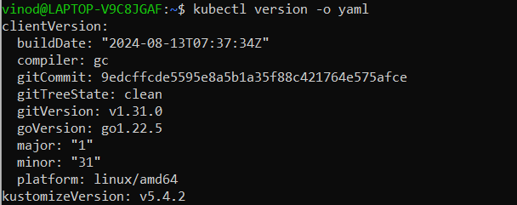

minikube start --driver=docker

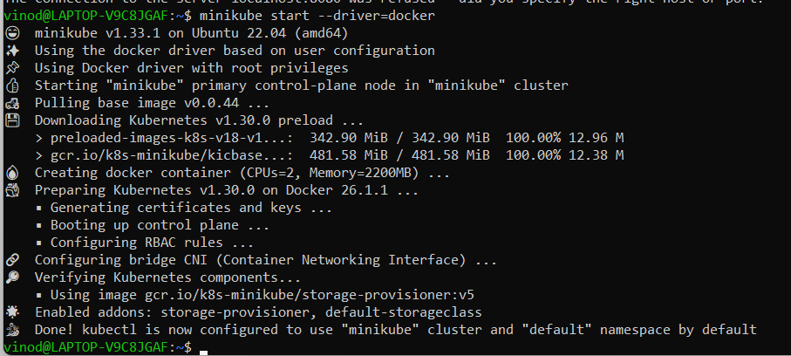

minikube status

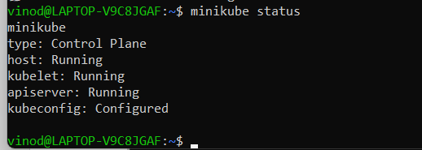

kubectl get nodes

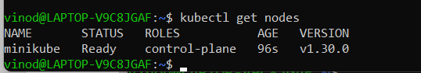

kubectl get namespaces

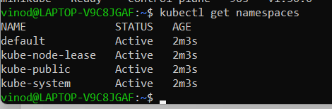

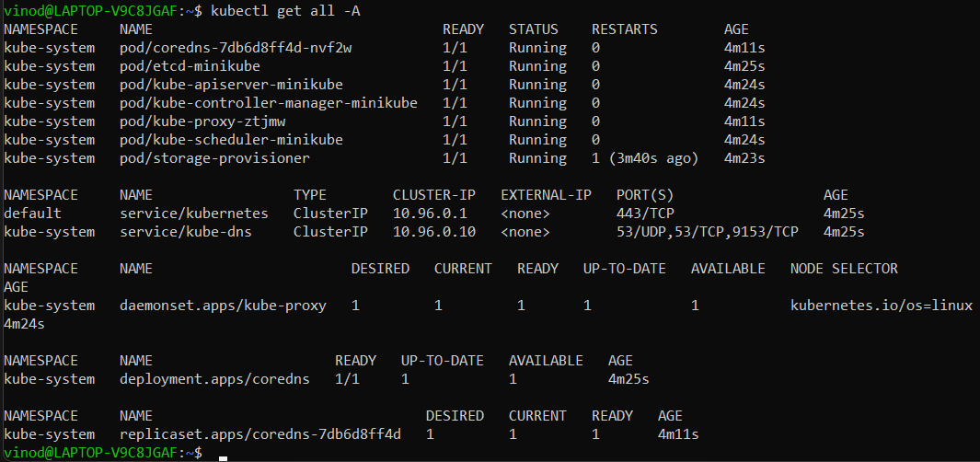

curl https://baltocdn.com/helm/signing.asc | gpg --dearmor | sudo tee /usr/share/keyrings/helm.gpg > /dev/null

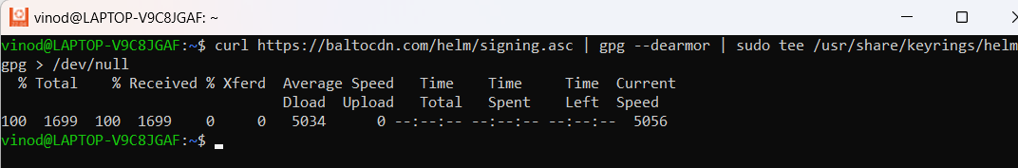

sudo apt-get install apt-transport-https –yes

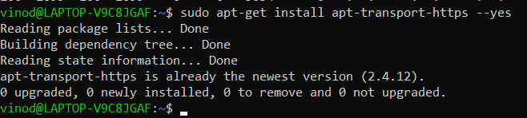

echo "deb [arch=$(dpkg --print-architecture) signed-by=/usr/share/keyrings/helm.gpg] https://baltocdn.com/helm/stable/debian/ all main" | sudo tee /etc/apt/sources.list.d/helm-stable-debian.list



sudo apt-get update

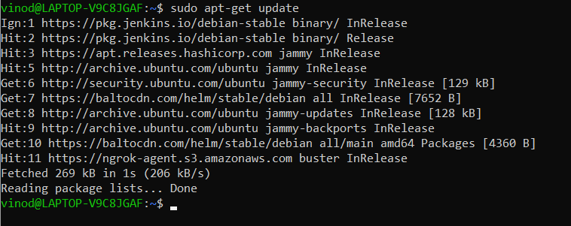

sudo apt-get install helm

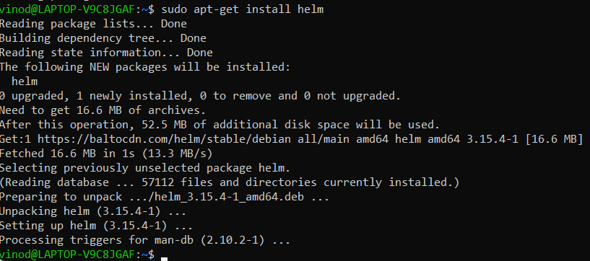

curl -fsSL -o get_helm.sh <https://raw.githubusercontent.com/helm/helm/main/scripts/get-helm-3>

chmod 700 get_helm.sh

./get_helm.sh

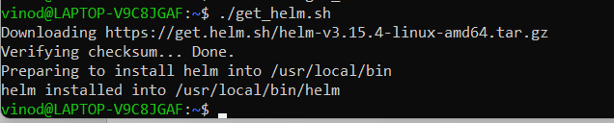



helm repo add prometheus-community https://prometheus-community.github.io/helm-charts

helm repo update

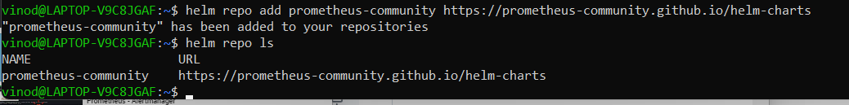

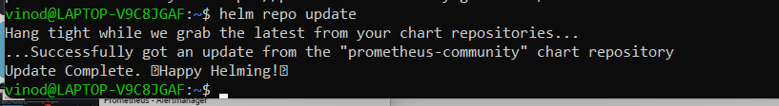

helm search repo prometheus-community

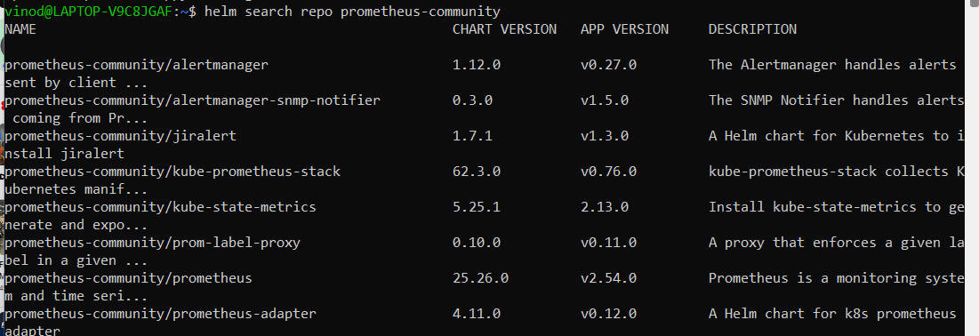

Setup Prometheus.yaml

helm install prometheus prometheus-community/prometheus -f prometheus.yaml

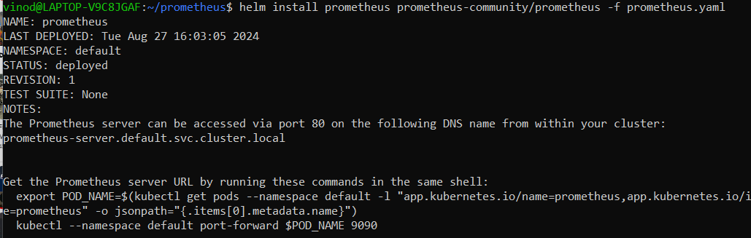

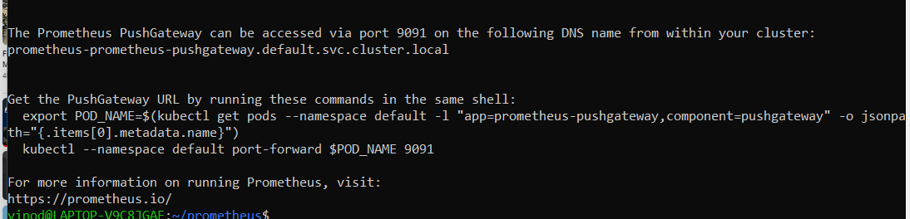

export POD_NAME=$(kubectl get pods --namespace default -l "app.kubernetes.io/name=prometheus,app.kubernetes.io/instance=prometheus" -o jsonpath="{.items[0].metadata.name}")

kubectl --namespace default port-forward $POD_NAME 9090

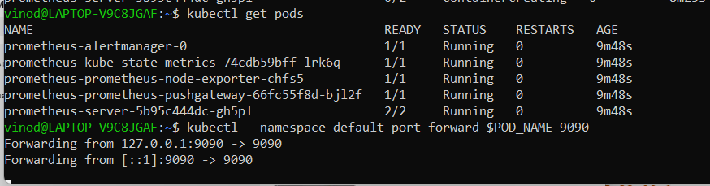

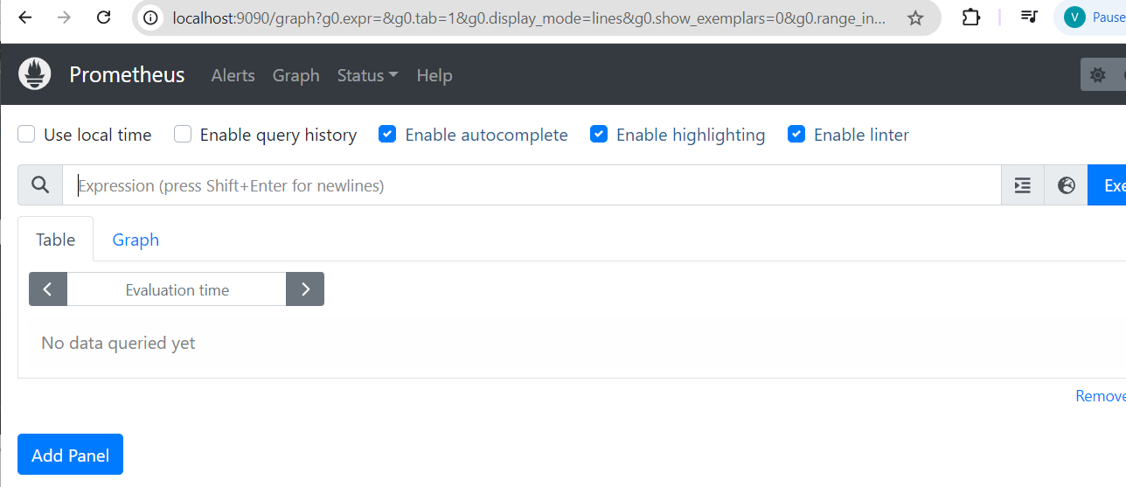

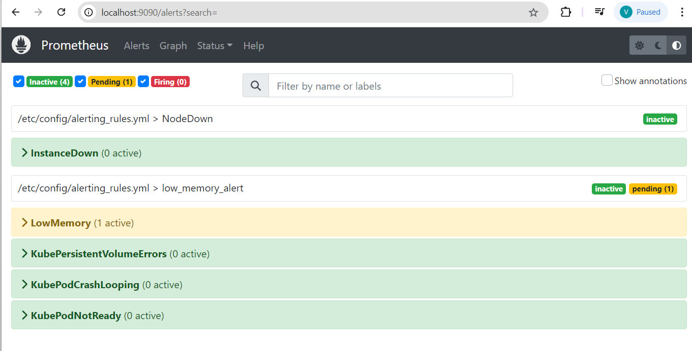

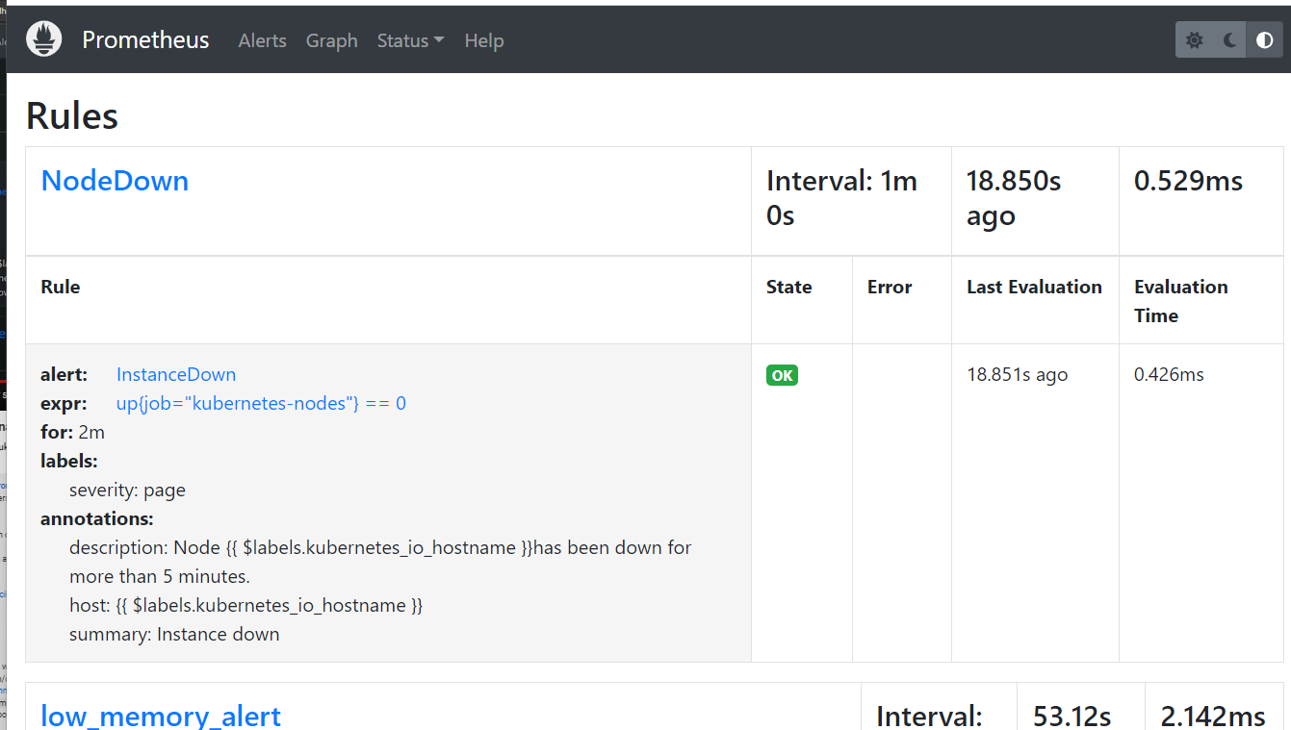

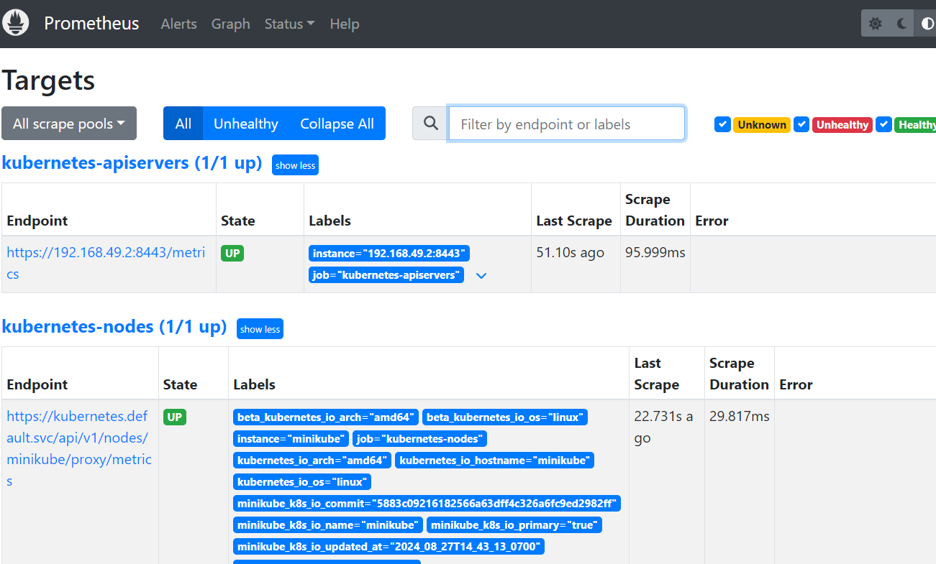

kubectl expose service prometheus-alertmanager --type=NodePort --target-port=9093 --name=alertmanager-access

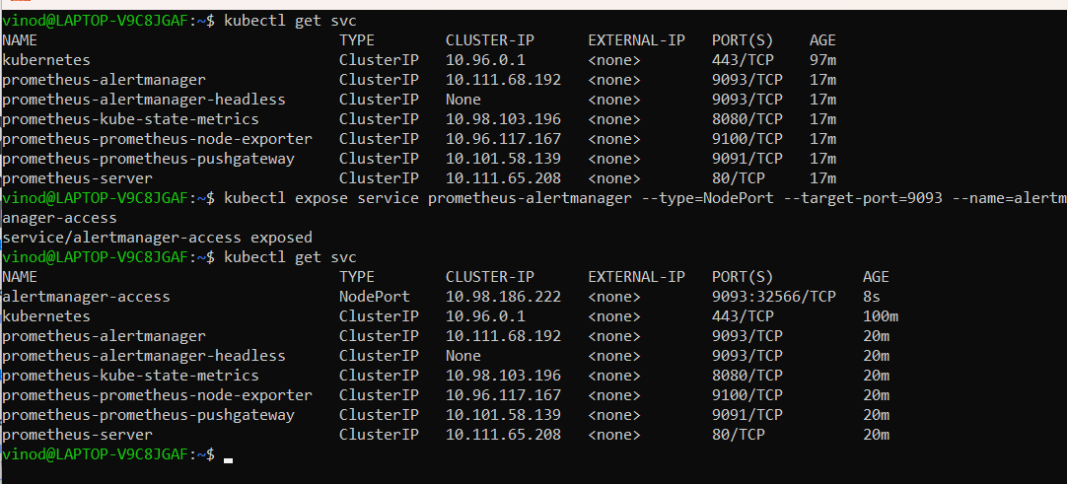

export POD_NAME=$(kubectl get pods --namespace default -l "app.kubernetes.io/name=alertmanager,app.kubernetes.io/instance=prometheus" -o jsonpath="{.items[0].metadata.name}")

kubectl --namespace default port-forward $POD_NAME 9093

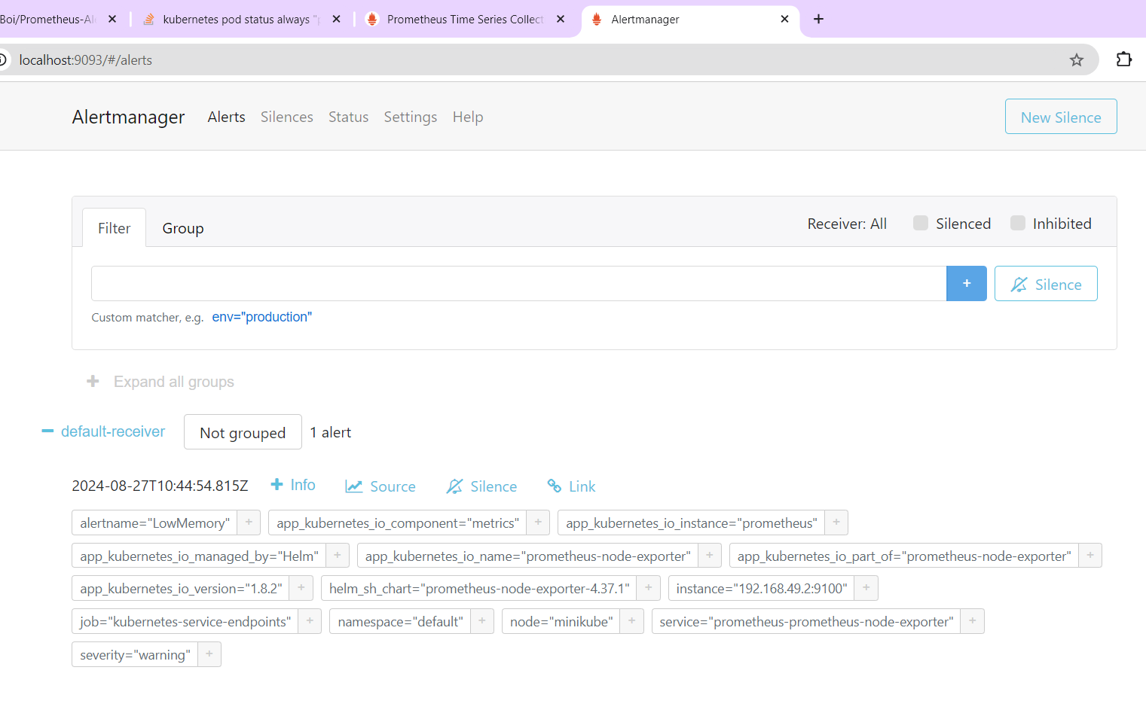

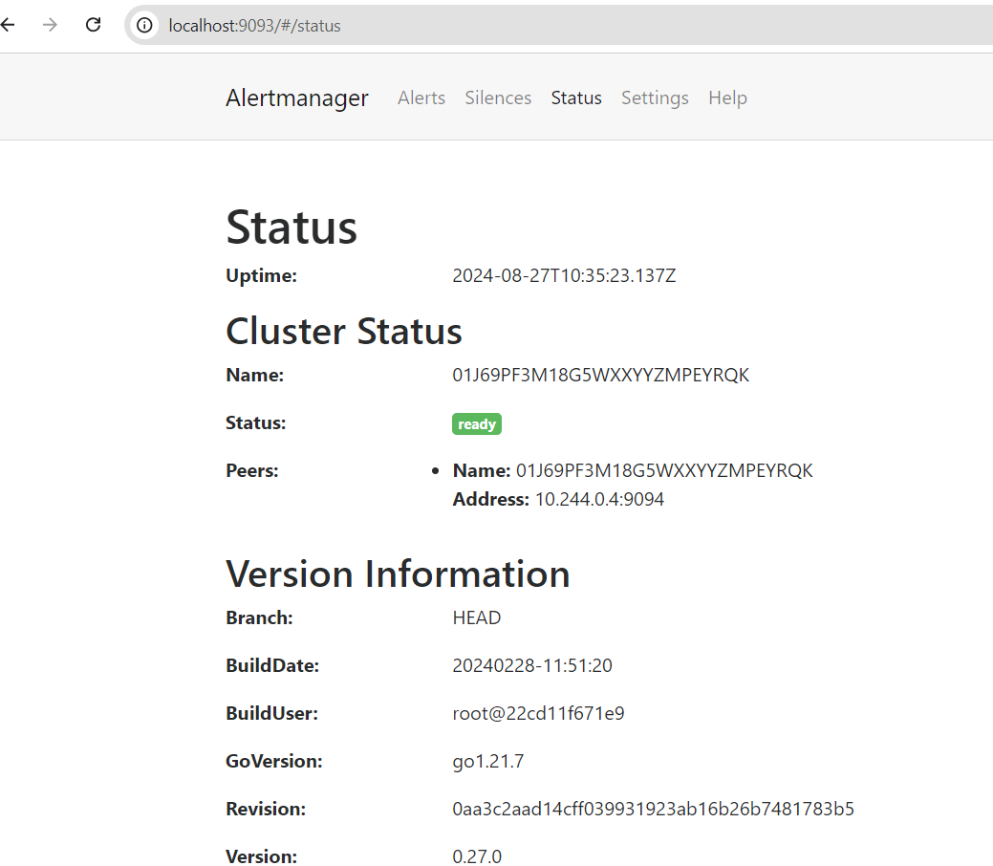

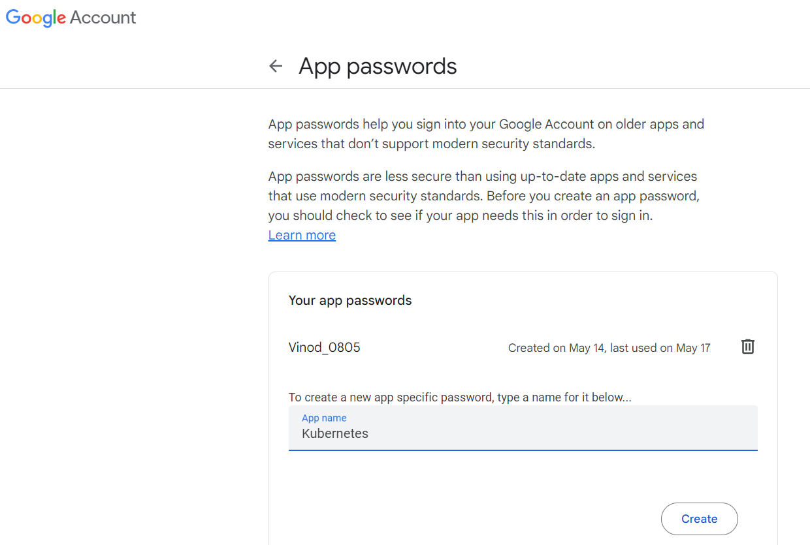

kubectl get configmaps

kubectl edit configmap prometheus-alertmanager



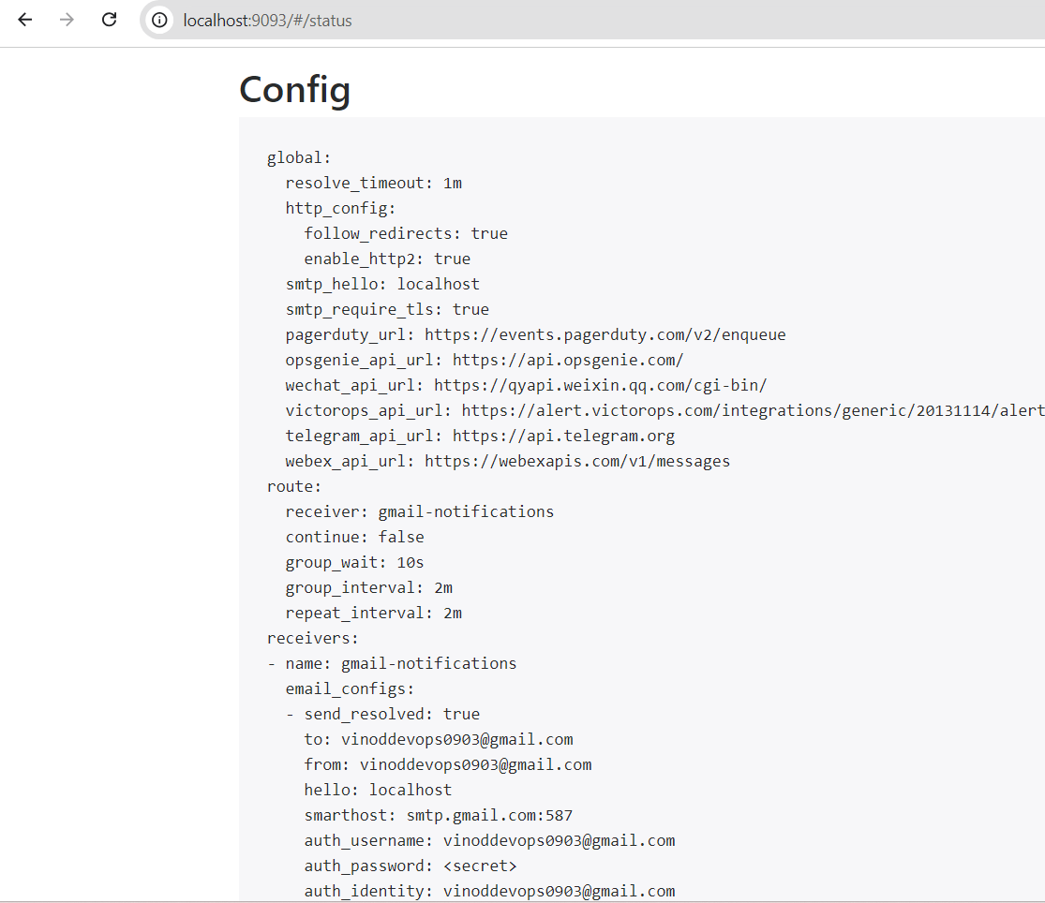

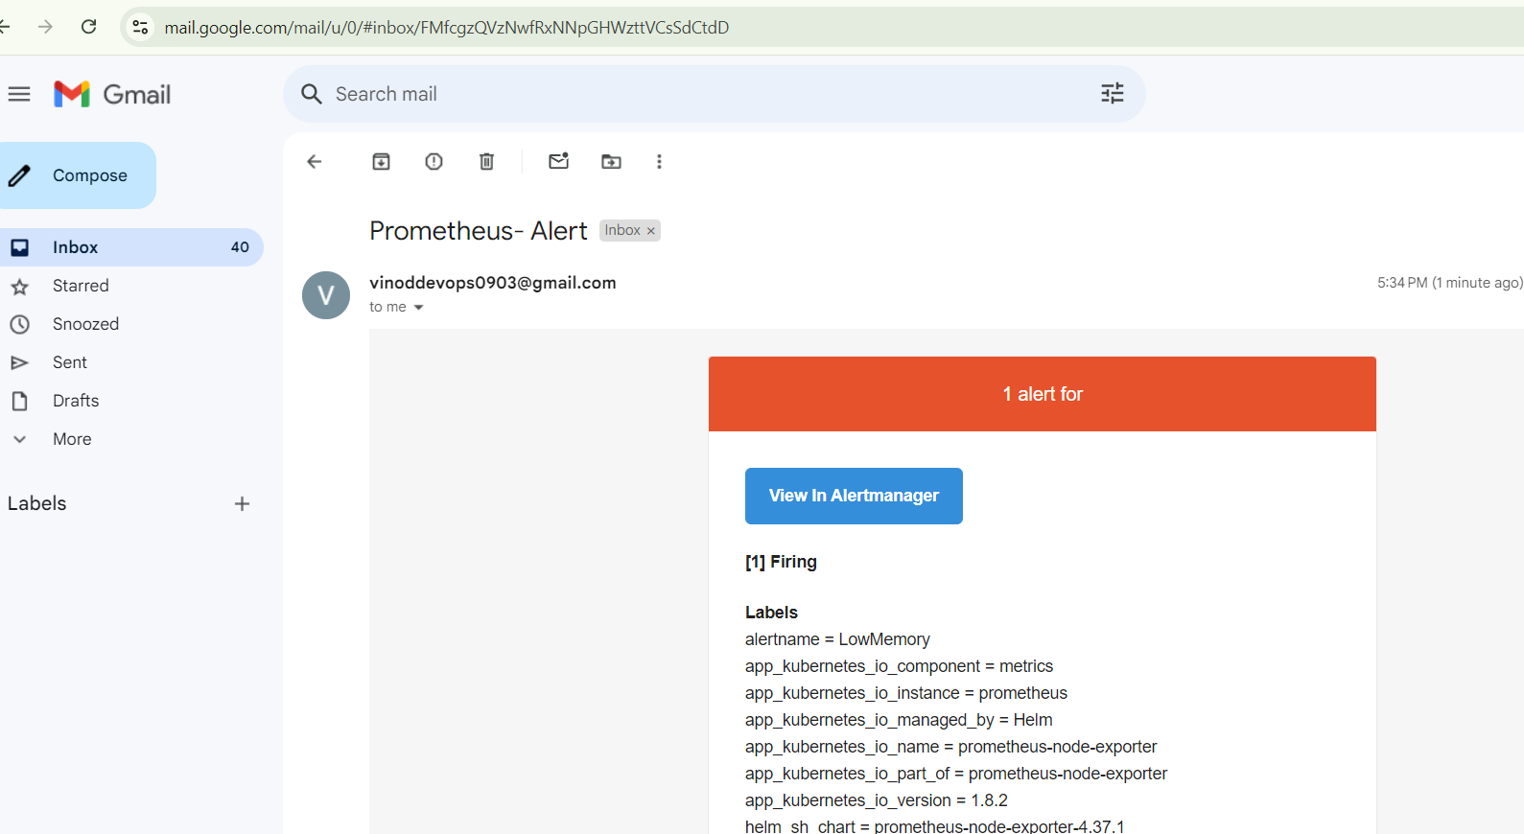

helm repo add grafana https://grafana.github.io/helm-charts

helm repo update

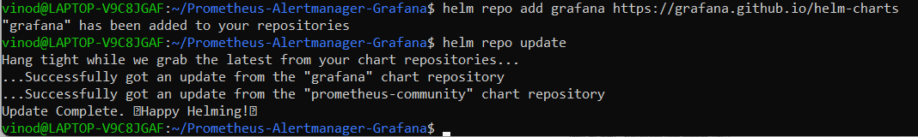

helm search repo Grafana

helm install grafana grafana/Grafana

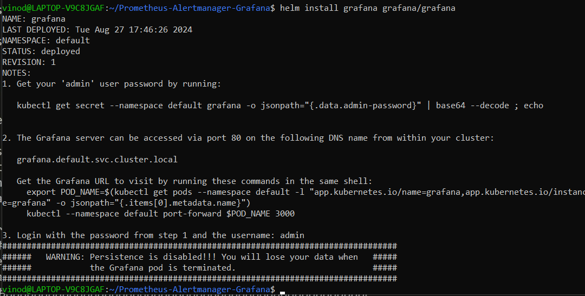

kubectl get secret --namespace default grafana -o jsonpath="{.data.admin-password}" | base64 --decode ; echo



